
Enterprise Banking Microservices
Team:
Sonu 2520090204
Rithesh 2520090122
Suresh 2520090036
A scalable and secure distributed banking backend — course project for
Database Systems Engineering and Distributed Backend Development.\

Problem Statement
Traditional banking systems struggle with growth,
Project goal: build a secure, modular security, and operational complexity. Key challenges:

microservices platform managing customers, accounts, transactions, and fraud detection.
- Scaling for high transaction volumes
- Secure authentication and authorization
- Consistent, reliable transaction processing
- Managing payments and account state across services
- Detecting suspicious/fraudulent behavior in real time

Project Objectives
Secure Architecture
Implement authentication,
authorization, and secure REST
APIs.
Scalability
Microservices design to scale
individual capabilities
independently.
Transaction Integrity
Consistent account balances and
reliable transaction logging.
Fraud Detection
Identify suspicious patterns and flag high
-
risk activities.
User Experience
Clean frontend: registration, dashboard, transfers, and
forms.

Literature Survey — Summary
Reviewed domains and high-level findings. (Final slide will list exact papers and citations.)

Microservices Architecture
Improves modularity and scale; introduces distributed communication and consistency challenges.

Secure Authentication
Token-based auth and role-based access control are effective but need careful token lifecycle management.

Banking Transaction Systems
ACID semantics support correctness; scaling requires careful partitioning and compensating transactions.
Research gap: Few works integrate scalable microservices, strong transactional guarantees, and inline fraud
detection in a single platform.

Fraud Detection
Pattern-based and ML approaches detect anomalies; accuracy depends on data richness and labeled examples.

Proposed System — Overview
We propose a microservices-based banking platform exposing secure REST APIs. Core capabilities:
- Customer management and registration
- Authentication & authorization (token-based)
- Account and balance management
- Secure money transfers and payment recording
- Transaction ledger and audit trails
- Real-time fraud detection and alerting
Technology stack: React.js (frontend) → FastAPI (microservices) →
MySQL (persistent store)

System Architecture — Flow
Frontend (React) handles UI and client validation. FastAPI services implement business logic per bounded context (auth, accounts, payments, fraud). Services communicate over REST (HTTP) and use MySQL for persistent state. Fraud service subscribes to transaction events for near-real-time scoring.

Modules & Responsibilities
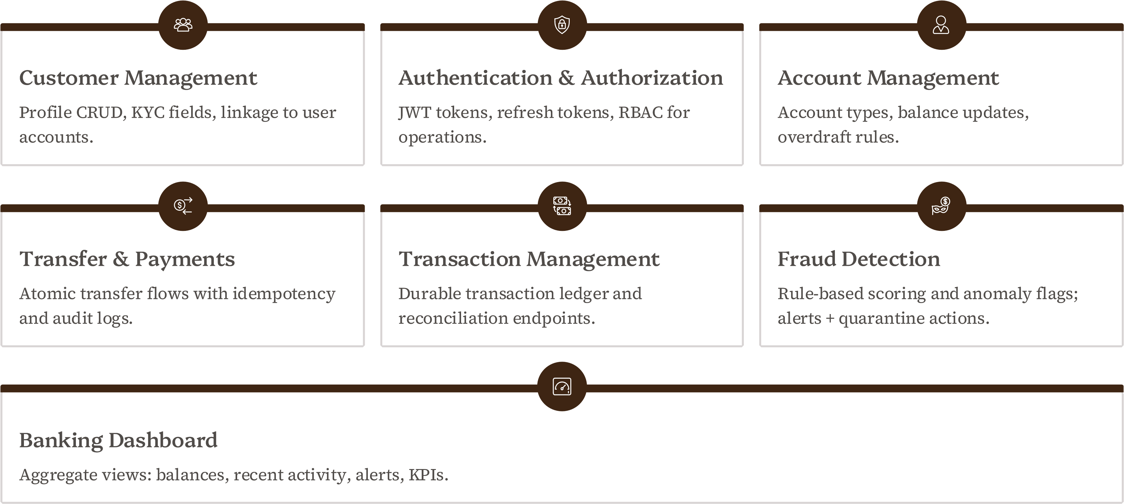

Frontend Design (Simple & Human)
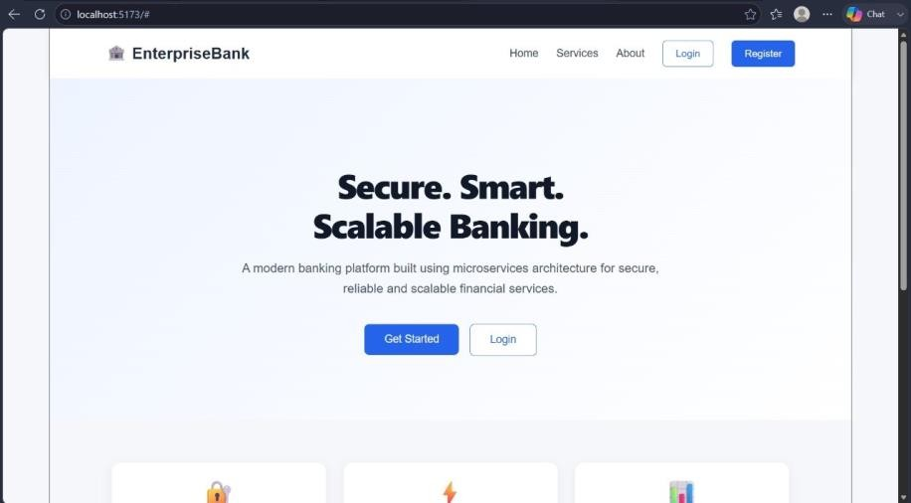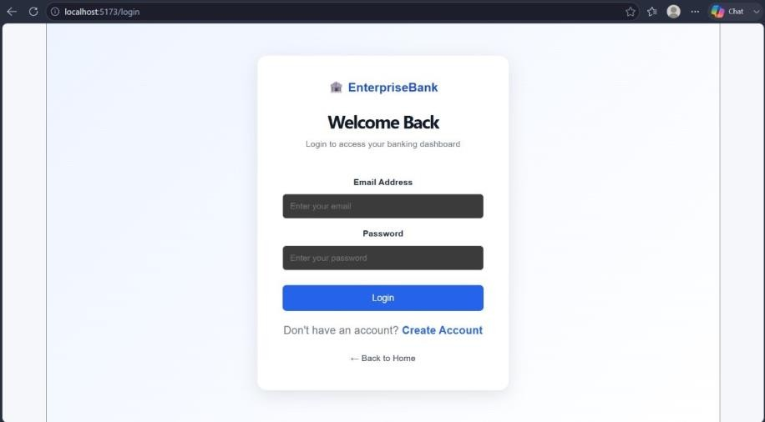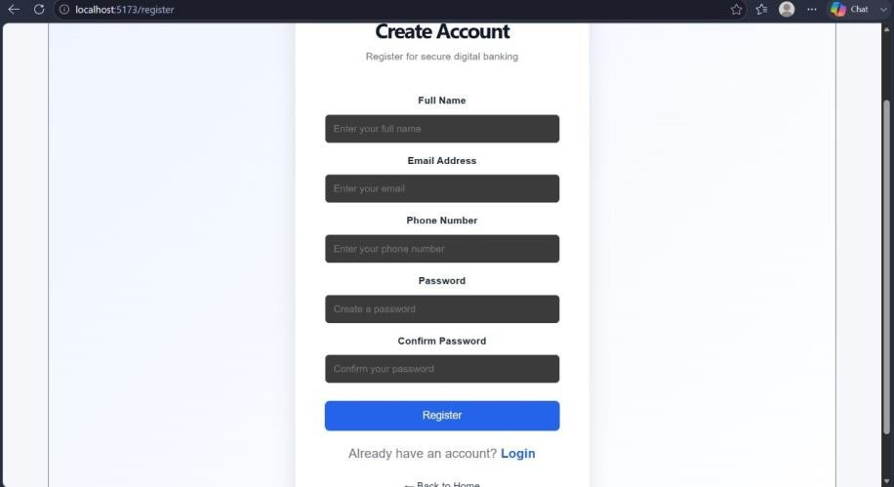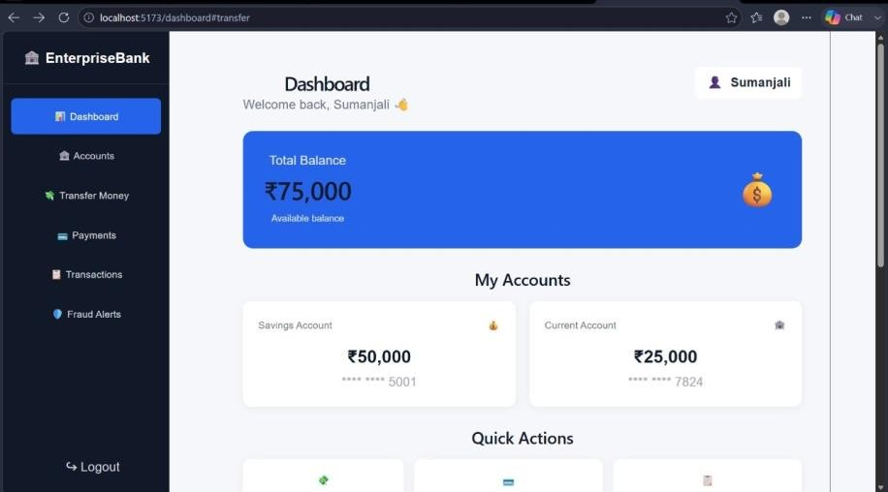

Frontend Design (Simple & Human)
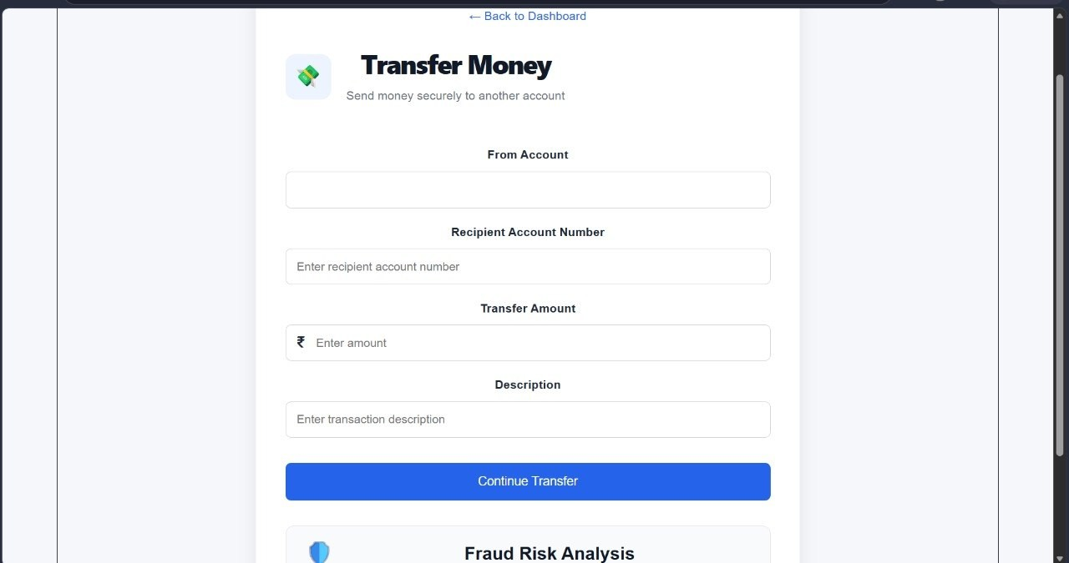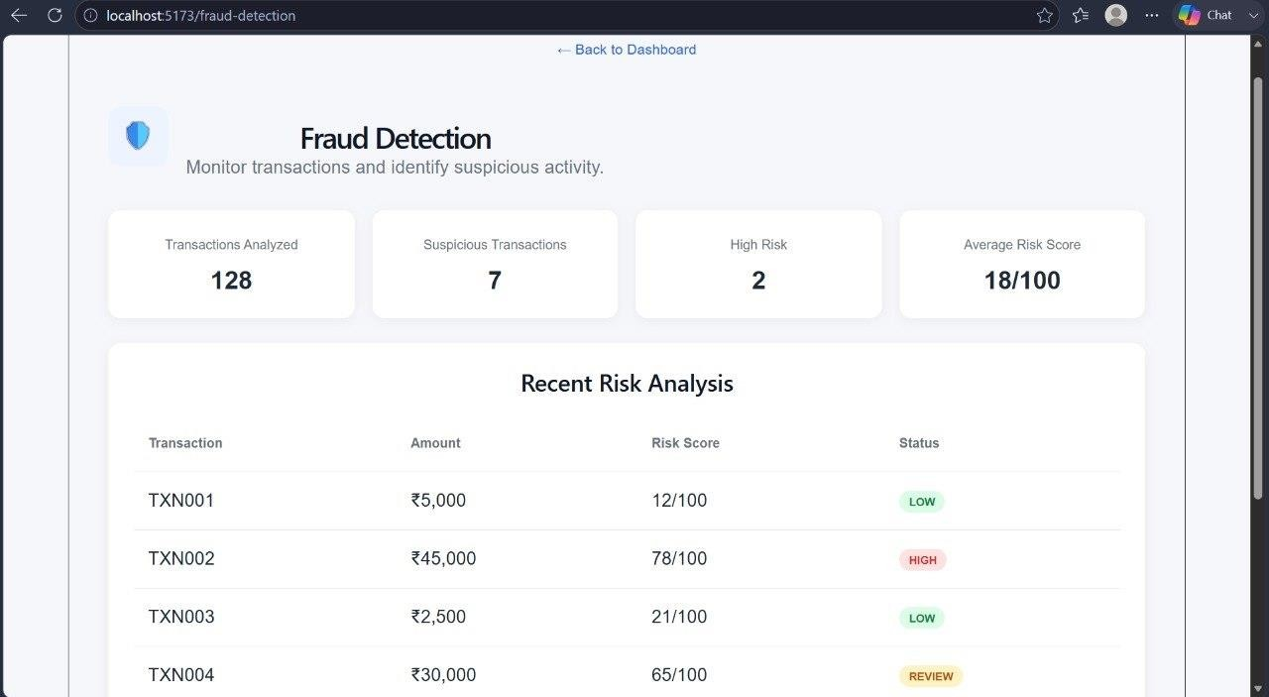
Database Design — Conceptual
MySQL relational schema — main tables and key relationships:
- customers (customer_id, name, KYC, contact_info)
- users (user_id, customer_id, username, password_hash, roles)
- accounts (account_id, customer_id, balance, currency, status)
- transactions (tx_id, from_account, to_account, amount, status, timestamp)
- payments (payment_id, account_id, payee, amount, method, status)
Relationships: customers→users (1:N), customers→accounts (1:N), accounts→transactions (1:N). Use indexes on account_id, customer_id, and transaction timestamps for performance.

Next Steps & Implementation Plan
01 02

Phase 1 — Core Services Phase 2 — Transfers & Idempotency
Implement auth, customer, accounts, and transaction Design atomic transfer flows, idempotency keys, and services with MySQL persistence and API contracts. reconciliation endpoints.
03 04

Phase 3 — Fraud Detection Phase 4 — Frontend & Testing
Integrate rule-engine, event stream ingestion, and alerting; Polish UI, add screenshots (presenter to insert), run evaluate ML models with labeled data. integration and load tests; prepare final paper with citations.
Deliverables: working microservices, API documentation, dataset for fraud evaluation, final report with literature citations.
Enterprise Banking
Microservices — Architecture & Implementation
Concise technical overview for graduate-level reviewers: schema, backend design, auth, transfers, fraud detection, and next steps. Theme accents: #3E2513 and #F3E3D8.

Agenda
Data Model
ER diagram & key schema tables
Sample Data
Representative MySQL rows and
snapshot
Backend & Security
FastAPI, JWT, bcrypt, protected
endpoints
Transfers & Fraud
Flow, atomicity, DBSCAN anomaly detection
Challenges & Roadmap
Integration, deployment, advanced alerts
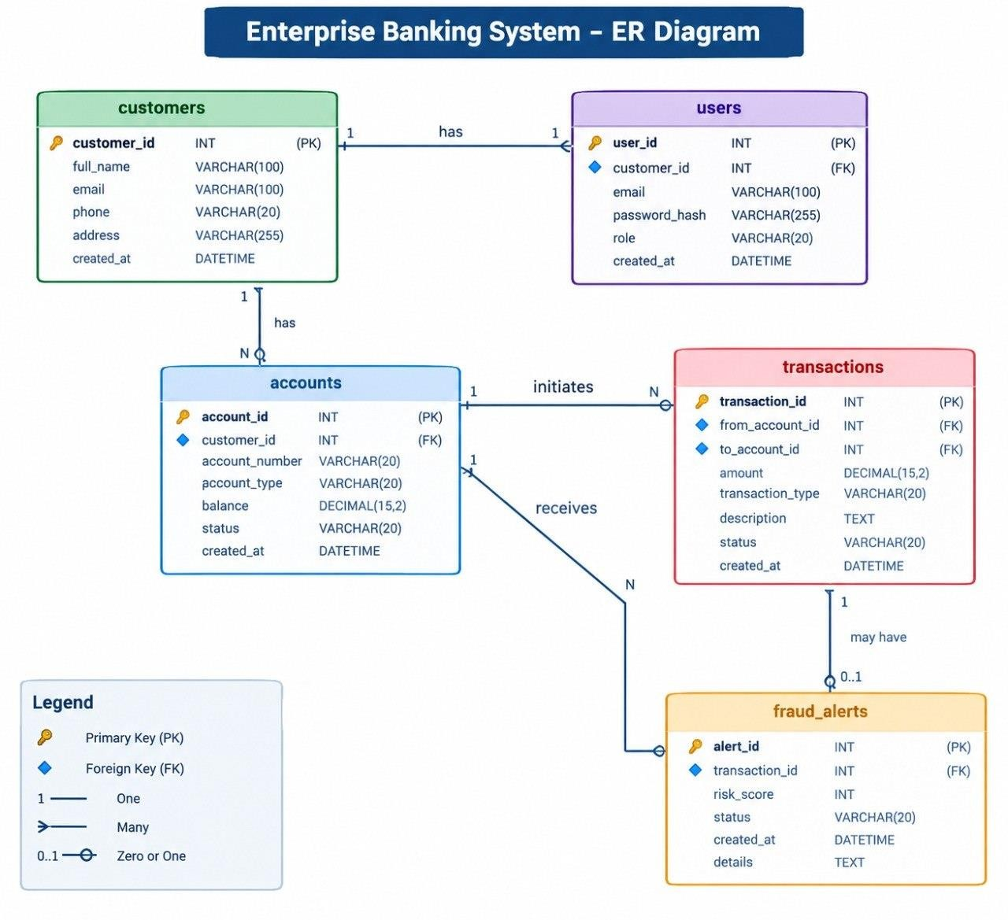
ER Diagram — Core Entities
Visual: customers, users, accounts, transactions, payments with PK/FK links (customers ← users, customers ← accounts, accounts ← transactions, transactions ← payments). See diagram for primary/foreign-key relationships and cardinality.
Schema — Key Tables (selected columns)

Customers
- customer_id (PK)
- full_name
- email
- phone
- address
- created_at

Users
- user_id (PK)
- customer_id (FK → customers.customer_id)
- email
- password_hash
- role
- created_at

Accounts
- account_id (PK)
- customer_id (FK → customers.customer_id)
- account_number
- account_type
- balance
- status

Transactions / Payments
transaction_id (PK), account_from_id (FK), account_to_id (FK), amount, currency, timestamp, status, payment_id (FK optional)

Sample Records — Accounts (MySQL)
Representative rows pulled directly from MySQL (formatted):
account_id | customer_i d | account_no | type | balance
1 | 1500 | SAVINGS | 115001SAVI  NGS | ₹50,000
2 | 17824 | CURRENT | 217824CUR  RENT | ₹25,000
3 | 26001 | SAVINGS | 326001SAVI  NGS | ₹40,000
4 | 37001 | SAVINGS | 437001SAVI  NGS | ₹30,000

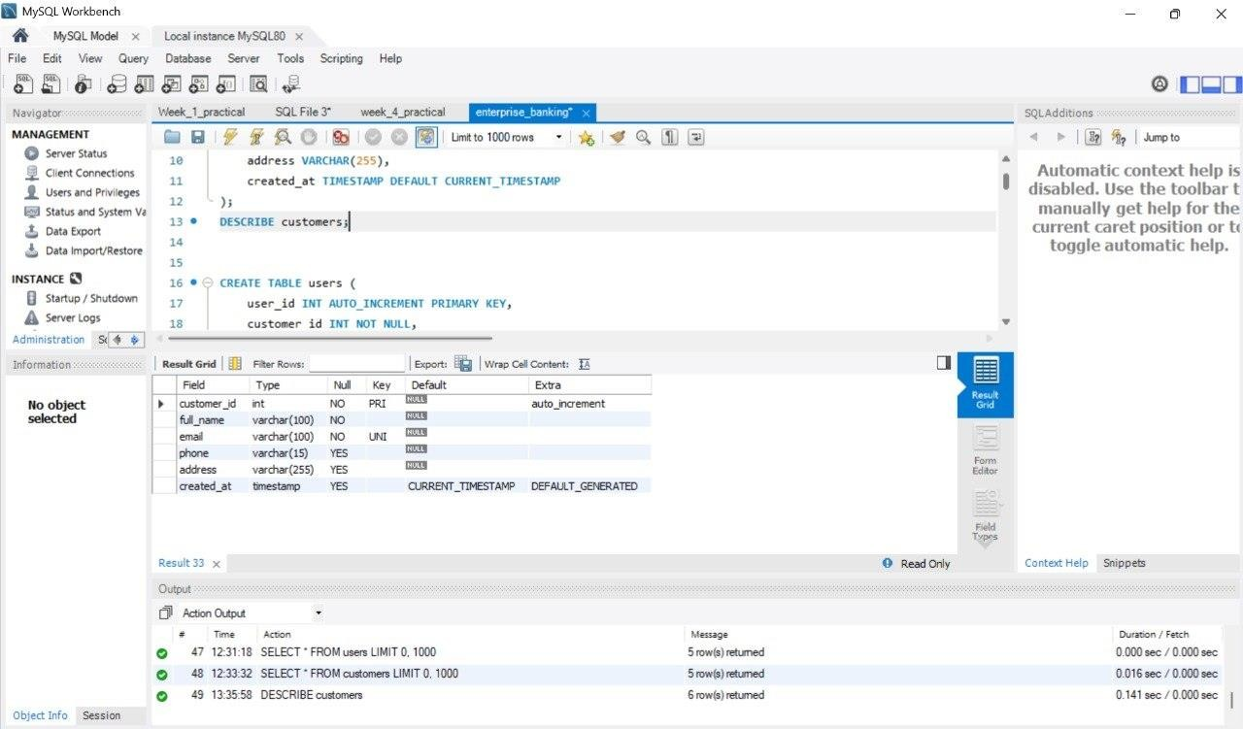
Small MySQL output snapshot (for auditor verification).
There was an error generating this image
Statuses: ACTIVE for all shown. These rows are exact MySQL excerpts used for demonstrations and testing.

Backend Design — FastAPI Overview
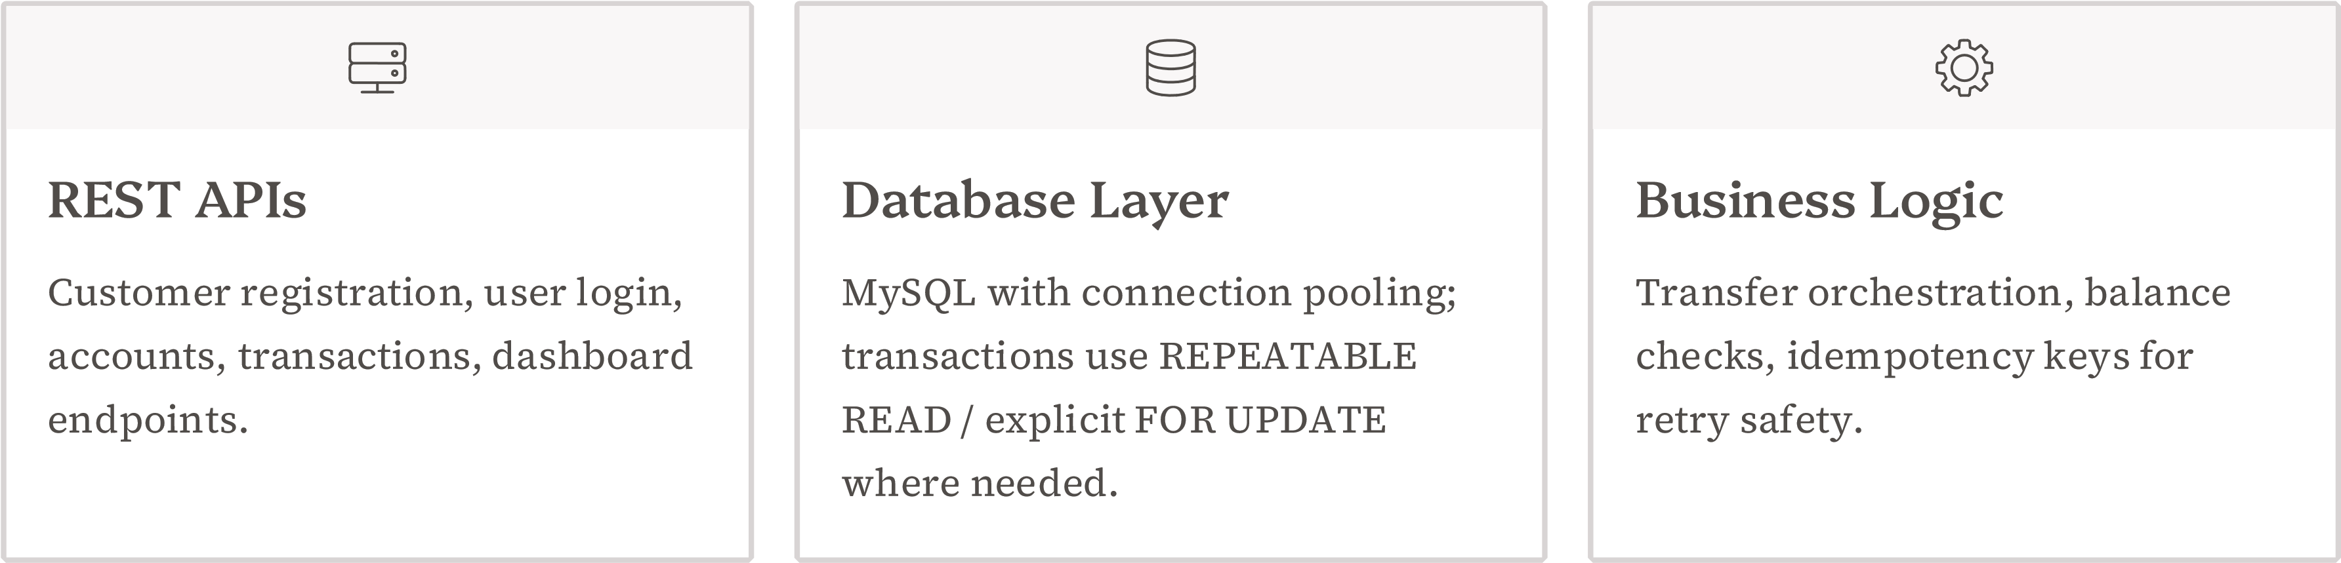

Authentication & Security
Flow: User → submit credentials → backend verifies bcrypt hash → generate JWT (exp, sub, roles) → client stores token → token used for protected endpoints.
- Bcrypt for password hashing and salting
- JWT with short expiry + refresh token pattern
- Role-based authorization checks at endpoint level
- HTTPS-only, secure cookies or Authorization header
Frontend
-
backend integration is incomplete; do not claim full
end
-
to
-
end UI connectivity.

Money Transfer — Flow & Example

Execute Transaction
Check Balance
Verify Ownership
Authenticate User
Example: Transfer ₹5,000 from Account 1 (₹50,000) to Account 3 (₹40,000) → Result: Account 1 = ₹45,000, Account 3 = ₹45,000. Use DB transactions with SELECT ... FOR UPDATE and idempotency keys to prevent double-spend.

Fraud Detection — Approach
Goal: surface anomalous transactions with low false positives while enabling automated flagging for human review.
- Feature set: amount z-score, velocity (tx/min), geo deviation, device fingerprint, payee history
- Model: unsupervised DBSCAN for clustering typical behavior; outliers → risk scores
- Pipeline: batch score (nightly) + streaming alerts for high-risk tx

DBSCAN is chosen to detect density-based outliers without labeled fraud data; tune eps/min_samples and normalize features.

Challenges, Roadmap & Conclusion

Key Challenges
Maintaining transactional integrity, secure credential storage, safe retry semantics, and robust fraud signal integration.

Next Steps
Complete React–FastAPI integration, wire fraud model into transaction API, add payment provider integration, containerize with Docker and deploy to cloud.

Conclusion
Modular stack (React + FastAPI + MySQL + JWT) provides a secure, extensible foundation for banking features and analytic extensions. Prioritize safe transfer semantics and fraud integration before production rollout.

